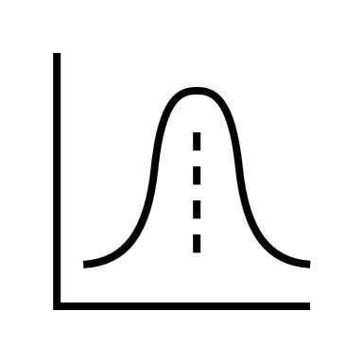

Let $f\left(x,y\right):R→R^{2}$. For some $c∈R$:

$$f\left(x,y\right)=\left\{\begin{aligned}ce^{-x^{3}y}, for x>1 and y>0 \\ 0, otherwise\end{aligned}\right.$$

For what value of $c$ is $f$ a joint density function?

**Solution**

**Answer**

